**Introduction**

A digital watermark is an additional signal embedded in the original one. It is used to store other data (e.g., metadata) directly with the original signal. Watermarks are commonly used in audio and video content.

The purpose of the exercise is to implement a simple digital watermark algorithm. The implementation of the algorithm Least Significant Bit (LSB) [1] should allow to read and write binary metadata from the image.

Laboratory materials to download:

Grayscale Lena image: <http://kt.agh.edu.pl/~matiolanski/Dydaktyka/lena512g.bmp>

Color Lena image: <http://kt.agh.edu.pl/~matiolanski/Dydaktyka/lena512.bmp>

**Exercise**

Please boot the computer and log in. Choose the OS you are most familiar with.

LSB

The algorithm operates on a binary pixel representation of the image. LSB algorithm replaces the value of each pixel of the appropriate number of bits (starting with the least significant bits).

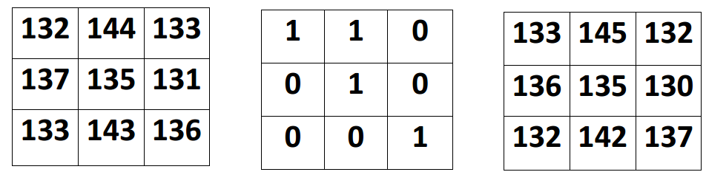

**Image Watermark Embedded image**

In the above example image is embedded with 110010001 messages. Read a watermark is done by analyzing the values ​​of the individual pixels.

Task

• Implement LSB algorithm in MATLAB [2] for grayscale and colour images. (Note: You can also write code in C++ or Python.)

• Try to embed an image with random binary string and read it after. Use 1, 2, 3, n least significant bits. How many bits can you save?

• Try to manipulate the image with watermark (e.g., resize, rotate). Can you read watermark after the manipulation?

• How is image quality changing when the watermark is embedded? Check the image quality using PSNR [3] or SSIM [4]. Create a dependency graph between image quality and a number of embedded bits (for each number of least significant bits).

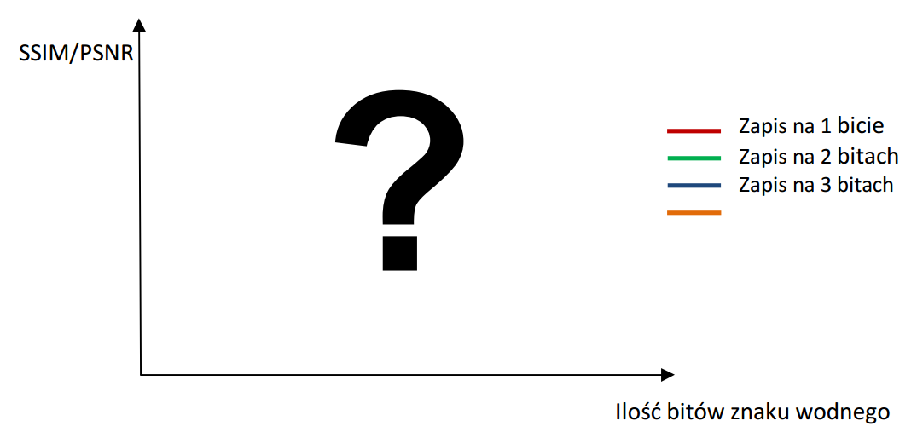

**Number of embedded bits**

**1 least significant bit**

**2 least significant bits**

**3 least significant bits**

**4 least significant bits**

**References**

[1] I. Cox - Digital Watermarking and Steganography, 2007

[2] E. Gonzalez - Digital Image Processing Using MATLAB, 2004

[3] PSNR, <http://en.wikipedia.org/wiki/Peak_signal-to-noise_ratio>

[4] SSIM, <http://en.wikipedia.org/wiki/SSIM>

[5] Au O.: ‘Visually Detectable Halftone Image Watermarking’, <http://www.ee.ust.hk/~eeau/demo_halftoneWatermark_B.htm>

[6] Cole E.: ‘Hiding in Plain Sight: Steganography and the Art of Covert Communication’, Wiley Publishing, Inc., ISBN 0471444499, 2003

[7] Digimarc Corporation: ‘Digimarc Corporation’, <http://www.digimarc.com/>

[8] ‘Directory of Books, Journals & Conferences on Digital Watermarking and Digital Watermarking Assessment Tools’, <http://knowledgebase.aegisdrm.com/knowledgebase_digital_watermarking_drm.htm>

[9] Wayner P.: ‘Disappearing Cryptography, Second Edition – Information Hiding’, Morgan Kaufmann, ISBN 1558607692, 2002